A PROPOSED OFFERING OF
ONLINE POINT-OF-SALES AND INVENTORY SYSTEM FOR
THE BREW CAVE – BARITAN, MALABON

A Thesis Project Presented to the
Faculty of Datamex College of Saint Adeline, Inc.

In Partial Fulfillment of the Requirements for the
Degree of Bachelor of Science in Information Technology

By:
Bugawan, Angelo A.
Esguerra, Ma. Sophia M.
Cañada, Jessie
Hondrado, Acezzel Ann B.
Java, Marjorie V.
Labay, Prince Harold M.
Macaya, Lordy James S.
Manalastas, Vincent James G.
Obispo, Kent Allen A.
Ranara, Job Daniel B.
Roluna, Jhunmark E.
Tablate, Carl A.

Submitted: January 9, 2026

SYSTEM WIREFRAME

- Login Interface & Authentication Module
The interface features a split-screen layout. The left side (or floating card) contains the authentication fields, while the right side is reserved for a "Slideshow" aimed at displaying promotional images or the shop's branding. The background utilizes a coffee-bean motif consistent with "The Brew Cave" branding. 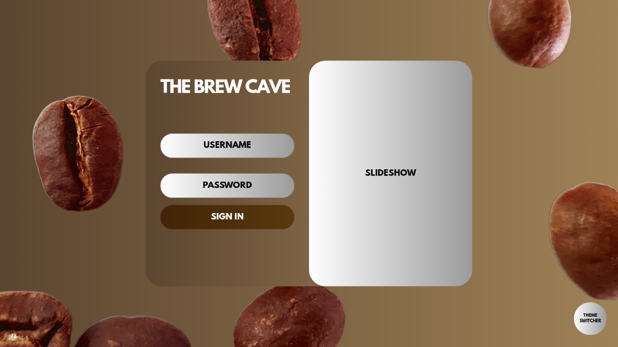
Functional Details:
  - Username & Password Fields: Standard input fields for secure access.
  - Sign In Button: Triggers the authentication query to the tbl_users database.
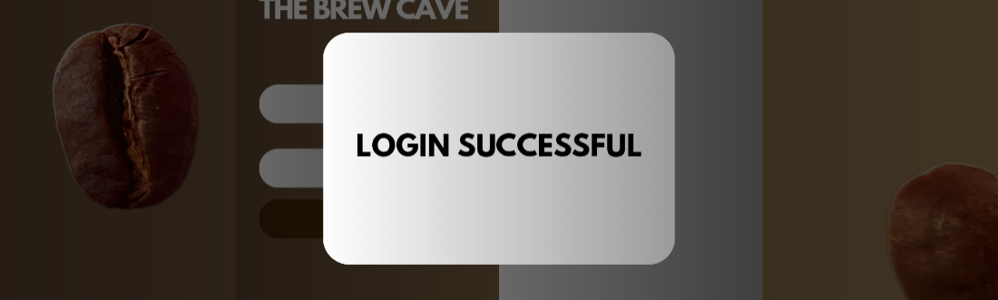
Login Successful Modal: A feedback overlay that confirms valid credentials before redirecting the user to the Dashboard. This prevents the user from wondering if the system froze.

- The Main Dashboard (Home & Overview)
The system utilizes a persistent Sidebar Navigation on the left (Home, Overview, Take Order, View Order, Stocks, Order History, User Management, Settings).
  - Home View: Features a "Date and Time Widget" for time-stamping and a "Priority Order Sneak Peek" to alert staff of urgent pending orders.
  - Profile Dropdown: A modal appearing from the top right allows users to "View Profile," check "Recent Actions," or "Sign Out."
  - Overview View: The analytics center. It displays summary widgets for "Total Checkouts," "Pending Orders," and "Login History." A large central block is reserved for "Statistics" (likely a sales graph).
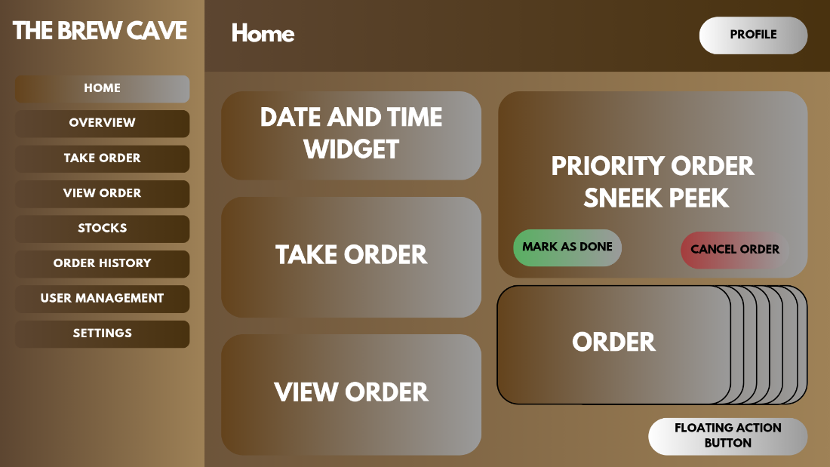
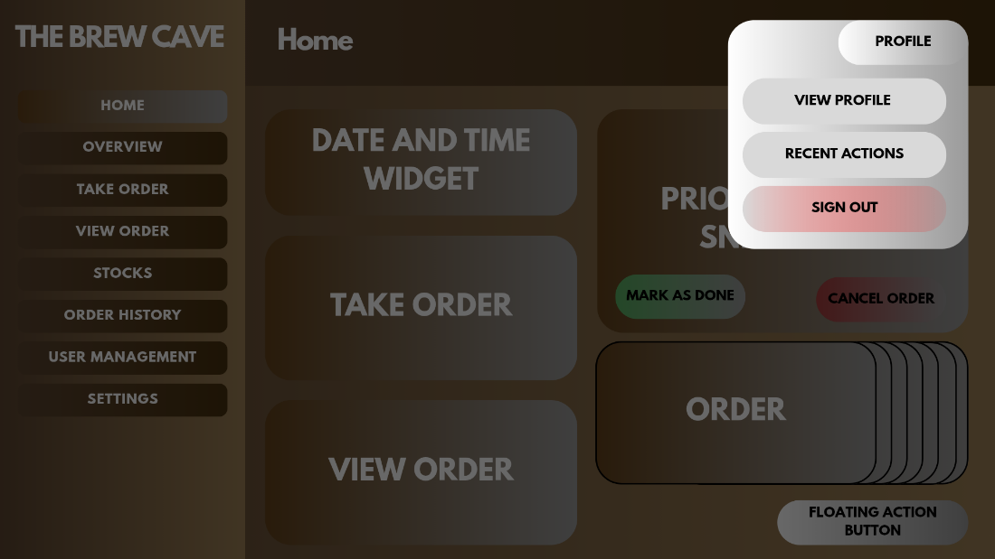
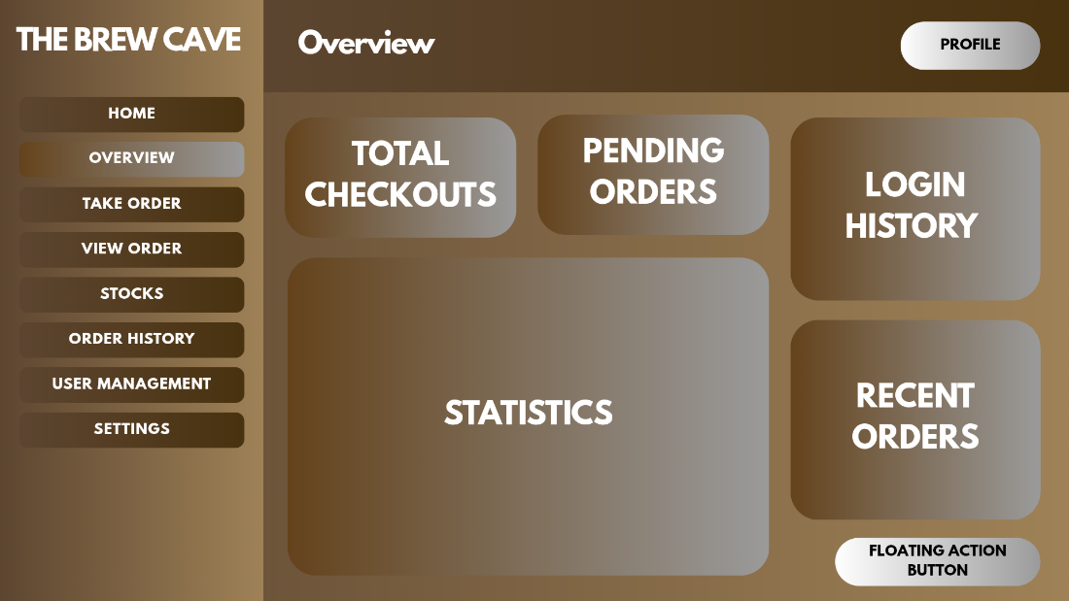
Technical Logic:
  - Real-time Data: The "Pending Orders" widget must refresh automatically (using AJAX or WebSockets) so the kitchen sees new orders instantly.
  - Floating Action Button: Located at the bottom right, likely a shortcut for "Full Screen Toggle" and "Refresh."

- Point of Sale (POS) Module
This is the heart of the operations. It features a Category Filter (All, Category 1, Category 2) at the top to sort drinks/food. The main area is a Grid Layout of large, touch-friendly "Item" buttons. 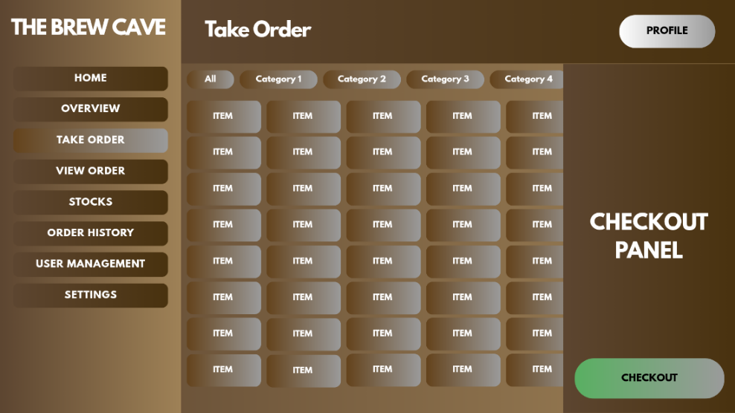
Right Panel (Checkout): A dedicated sidebar that lists selected items and totals, culminating in a green "Checkout" button.

- Order Management (Kitchen/Counter View)
A list view of active orders. Each row represents a transaction ("Example Order") with three distinct action buttons:
View: To see specific details (e.g., "Less Ice").
Mark as Done: To clear the order from the pending list (Kitchen done).
Cancel: To void the order.
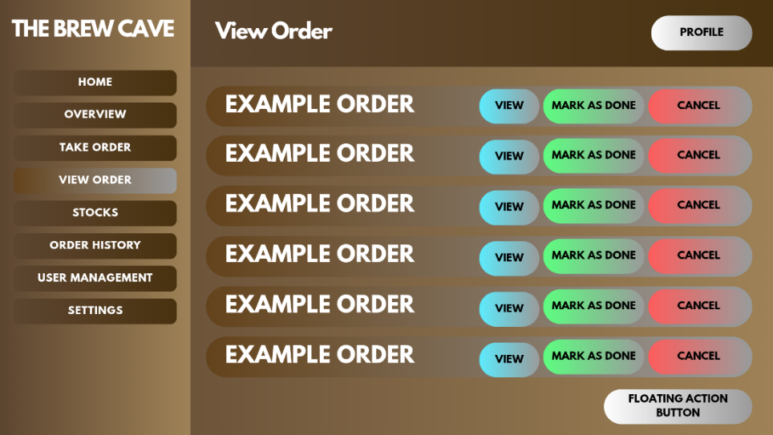

Technical Logic:
Clicking "Mark as Done" should trigger the Inventory Deduction (The Recipe Costing logic). This is the exact moment the milk and beans are subtracted from the database.

5. Inventory Management (Stocks)
A. tabular view of inventory items.
Action Buttons:
  - Add: To receive new stock delivery (e.g., +50 Cartons of Milk).
  - Drop: To record spoilage or spillage (e.g., -1 Carton dropped).
  - Delete: To remove an item from the system entirely.
  - Add Item Panel (Modal): A pop-up window allowing the admin to input details for new ingredients without leaving the main screen.
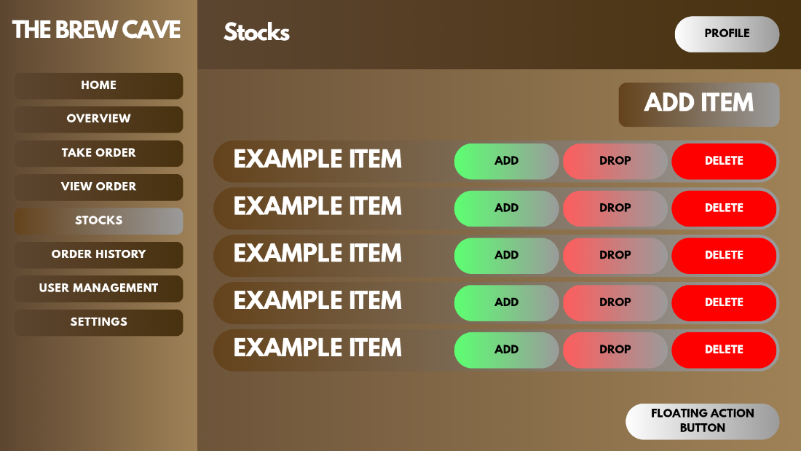
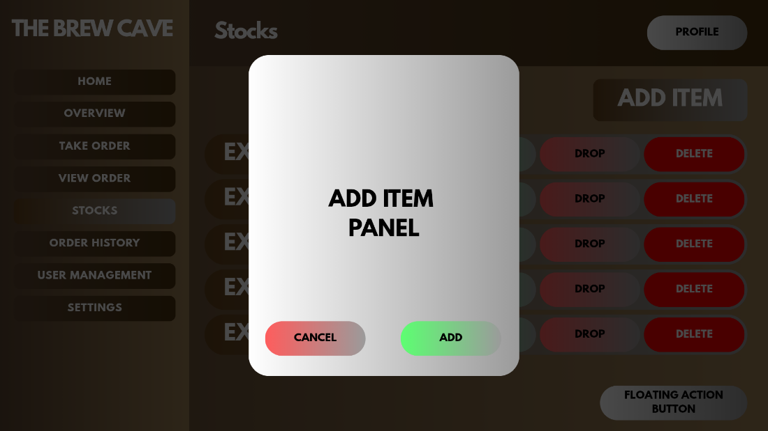

6. History & User Management
  - Order History: Shows past transactions with a "Refund" option. This solves the client's issue of "Unrecorded Sales" by keeping a permanent log.
  - User Management: Allows the Admin (Owner) to "View," "Add," "Modify," or "Delete" user profiles.
  - User Info Panel: A modal for editing specific staff details (Username, Password, Role).
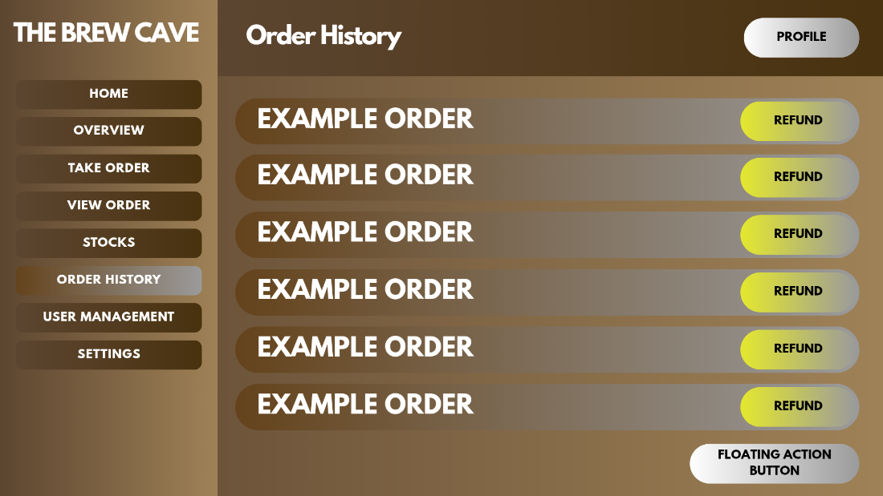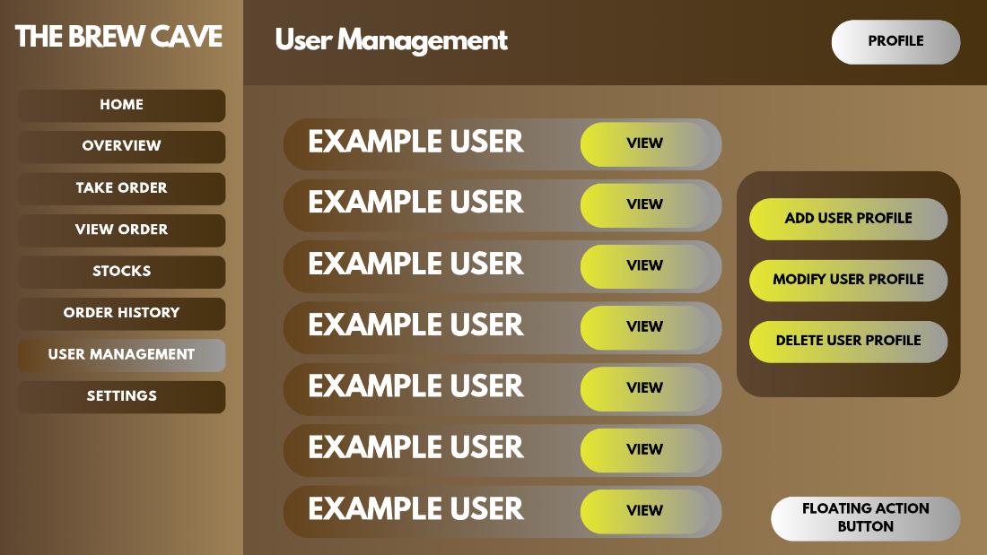
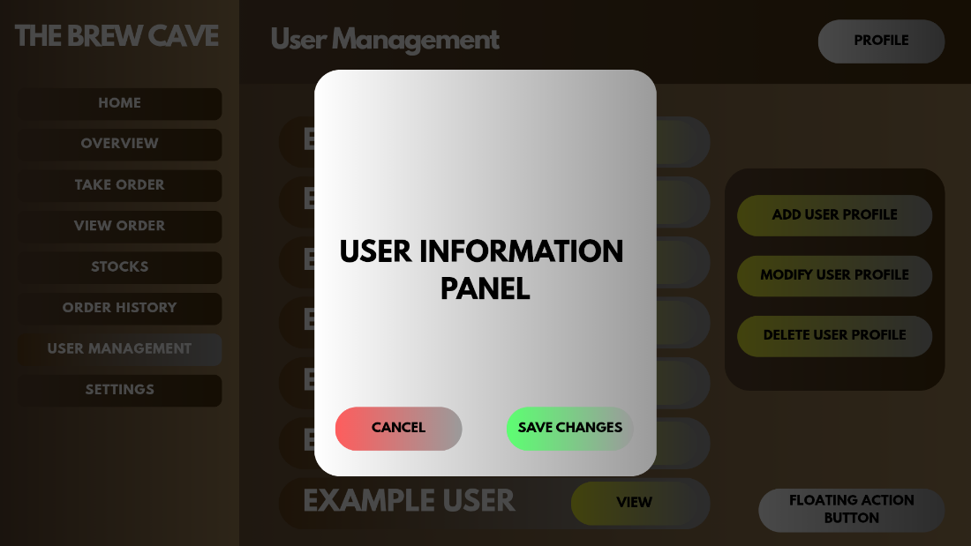

7. Settings
Divided into "General Settings" and "Other Settings." This is where you would place configurations for:
  - Tax Rates (VAT).
  - Printer Settings (for the thermal receipt printer).
  - Store Info (Address/Logo on receipt).
  - Sign Out Modal: A confirmation screen "Signing Out.." ensures the user knows the session has ended securely.
